1. INTRODUCTION

* 1. Purpose

The purpose of this financial module is to monitor and keep track of the bills being recorded by a store, and as well as its maintenance costs.

* 1. Documentation Conventions

For our system to work, It needs to make use of the following conventions.

|  |  |
| --- | --- |
| DB | Database |
| DDB | Distributed Database |

* 1. Intended Audience and Reading Suggestions

This system is meant for all varieties of stores. This system would be useful to the store management team and as well to the customers.

* 1. Project Scope

The purpose of this financial management module is to help ease financially related activities on the accounting and maintenance compartments in stores and to create a more efficient, reliable, accurate and sustainable means of effective managements of funds. This system will run on databases to accommodate valuable information. A server will be provided on the basis to store and help run the databases. All in all, we aim to provide a system that would drastically help manage funds within a store.

# Overall Description

2.1. Product Perspective

This financial management module consists of the following compartments :

• **Maintenance**

In other words, the upkeep section. Whereby details concerning how the store spends on its utilities/furniture to keep its structure maintained properly would be held. This compartment would consist of the following deliverables:

* Electricity fee
* Water fee
* Garbage fee
* Rent fee
* Internet fee

• **Account**

This section will entail of the bills recorded by the store. From here the administration will be able to keep track of each bill that’s going in and out of the store. This compartment would consist of the following deliverables:

* + Sales
  + Discounts
  + Credits
  + Debits

2.2. Product Features

The major features of our maintenance and accounting system are as shown in the entity-relationship model (ER diagrams) as shown below:

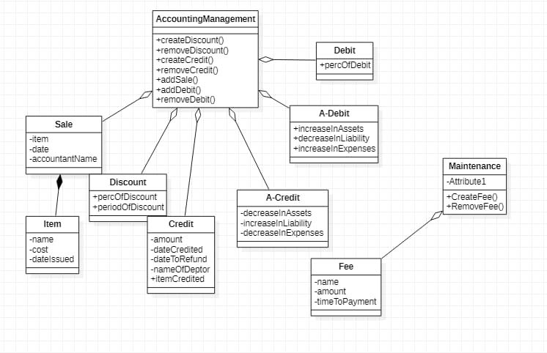

2.3. USER CLASS and CHARACTERISTICS

Users of this system should be able to use this system to effectively manage financial related activities in respect to accounting and maintenance within their store. Within this financial management system, consists of various functionalities that enables the user to carry out a sequence of related actions. Functionalities like ‘salary payments’ access should be limited only to the bursar/accountants of the enterprise. Customers will have access to customer functions, while the employee will have access to both customer and financial management functions.

The customer should be able to perform the following function:

• Pay Fees

* + Terminate subscribed services

The Employee should have the following management functions:

* + CUSTOMER FUNCTIONS
  + View all customers
  + View outstanding balances left by students to pay
  + View students who are late to complete payment

• ADMINISTRATIVE FUNCTIONS

* + Approve and verify payments
  + Authorize blocked services to students with completed payments - Update fee prices

2.4. Operating Environment

The operating environment for this financial module is as listed below

* + - Operating System: Windows, IOS and Android
    - Database: MySQL

# SYSTEM FEATURES

* DESCRIPTION and PRIORITY

The financial module keeps and manages information regarding finances within the school.

* FUNCTIONAL REQUIREMENTS

▪